The Birds of South Brent Parish

REVIEW and ADDENDUM 2018−25
The South Brent Parish Bird Survey (SBPBS) began in 2014 and, for the first three years, each of the 52 1-km squares (monads) comprising the parish was visited at least once every month by at least one experienced birder. The results were published by Brent Birders (2018) in The Birds of South Brent Parish. Since then, until 2024, the survey continued in reduced form to cover the winter and breeding periods, in January and May respectively, when all squares were visited during each month. In addition, casual records in other months and post−2024 continue to add to our knowledge of the South Brent avifauna.
The Birds of South Brent Parish (TBOSBP) was published in March 2018, and although it included records from 2017 and early 2018, it now needs updating. This Addendum, covering the period from 2018 to the end of 2025, includes additions to the parish list, records of other rare and scarce species, occurrences in new squares and months, new breeding records and some other observations of change. Much of the data is now in the form of Species Summaries compiled by Phil Dean, in a separate document South Brent Bird Survey 10-year anniversary.

Numbers of species
Before the survey started, 153 bird species, excluding escapes and introductions, had been recorded in the parish. The total includes Black Tern and Leach’s Petrel, overlooked in the historical records when compiling TBOSBP, but not the 2016 Lammergeier (not considered to be a truly wild bird: see p 25 of TBOSBP). Although only 139 species have been recorded since 2014, excluding known or likely escapes, this includes 13 not previously recorded in the parish, bringing the current parish total to 166. Their origins of the 13 are as follows:
Added during the 2014–16 survey and included in TBOSBP | 5 species
Added during 2017 and early 2018 and included in TBOSBP | 4 species
Added since the publication of TBOSBP | 4 species

Additions to the parish list from historical records (pre-2014, but not in TBOSBP)
- Black Tern. One picked up in a field at Aish on 27 Oct 1952 (Devon Bird Report 1952 and The Birds of Dartmoor by Roger Smaldon 2005). The first record for Dartmoor, presumably dead, and possibly long-dead as Smaldon refers to ‘remains’ being found.
- Leach’s Petrel. One found dead in a farmyard at South Brent 5 Oct 1983, (Devon Bird Report 1983).

Additions to the parish list since the publication of TBOSBP, in date order
- Common Rosefinch. One briefly on a bird feeder in a Sanderspool garden on 19 Nov 2019 (JD). A rare vagrant to Devon, mostly on Lundy, and only the third record for Dartmoor.
- Redshank. One at the Avon Dam on 16 Jul 2020, followed by singles on 24 Mar and 14 Jul 2025 (all PR).
- Cetti’s Warbler. Heard singing at Dockwell Hole on 31 May 2022, and subsequently on 1 & 10 Jun (PR, DS). Probably also the unidentified bird heard singing at the same site on 12 May 2021. Also, the first record for Dartmoor. The second for South Brent and Dartmoor was recorded on the Hope Wood site on 25 Jan 2025 (KN).
- Reed Warbler. Heard singing in Penstave Copse on 31 May 2023 (NC). (A warbler singing from riverside scrub above Shipley on 22 Jun 2018 (PR) was probably also of this species, but observer had reservations at the time: see Reay (2019) A Dartmoor Reed Warbler at last. Devon Birds 72(1): 23-25.)

Other taxa recorded only since 2017, but not added to the parish list
- ‘Italian’ Sparrow. A bird which closely resembled an Italian Sparrow (a hybrid between House and Spanish Sparrows) was first noted in a Hillside garden in Jan 2020 and recorded almost daily until Jun, then briefly in Oct 2020 and Jan 2021 (SH). In the absence of a DNA sample, the cautious identification is that it was an aberrant House Sparrow, so not included.
- White-fronted Goose. A bird of unknown origin and purity (perhaps an escaped hybrid) was first seen flying over the village with Canada Geese on 31 Mar and 3 Apr 2020 (PM), and later at the Avon Dam on 23 Apr and 6 May (PR). Not included in species totals as unlikely to be a truly wild bird but not previously recorded in the parish.

Species on the parish list recorded since 2017 but not during 2014–17, in date order
- Nightjar. One churring upriver from Shipley Bridge on 22 Jun 2018 (PR), was the first parish record since one in 1963 at Moorgate. Also heard and seen, with up to two birds, during May–Jul 2019 & 2020, but not subsequently.
- Crossbill. One over Stidston on 23 Apr 2019 (DS) was the first since one over the village in Jun 2013, itself the first since last recorded at Moorgate in 1975. Three feeding in a tall Sitka spruce at Didworthy on 17 Oct 2020 (MI) were probably the first in the parish seen other than in flight.
- Golden Oriole. One heard on 4 Jun 2021 at Moorgate (LH, RH, RP), was the first since one at the same site in Jun 1955, so only the second record for the parish.
- Whimbrel. One heard flying over the Dockwell area on 28 May 2022 (PR) was the first since one over Moorgate in Aug 1977. It was followed by one by the Avon Dam on 24 Apr 2024 (PR).
- Woodlark. One seen and heard (call and song) in the Avon Valley on 4 November 2022 (S&ND) was the first since 1972 at Moorgate, where it had previously bred.
- Hoopoe. One seen and photographed at Upper Webland Farm on 25 October 2023 (SP), was the first since one at Didworthy in 1973 and only the fourth record for the parish.
- Oystercatcher. One at the Avon Dam on 31 October 2023 (PR) was the first since one over Moorgate in 1963, and the first known to have landed in the parish.
- Shoveler. One at the Somerswood fishing lakes on 3 Jan 2025, was the first since a pair at the Avon Dam on 19 Mar 1959.

Other notable records since 2017
- Black Redstart in summer. In addition to regular autumn records, one on 5 Jul 2022 on the Avon Dam (PR) followed records from the same site on 21 Jul 2017 and 16 Aug 2016. Summer records on Dartmoor are unusual, and could indicate a breeding population nearby, though the species is not known to breed on Dartmoor or even, currently, in Devon.
- Cirl Bunting. A singing male below Brent Hill on 22 & 24 May 2019 (PR) was the first since Jul 2016, and only the fourth record for the parish. It was followed by records from the same area of singing males each year from 2022 to 2025 mostly May−Jul, but with extreme dates of 16 Apr and 12 Aug, and an outlier on 22 Oct. There were also a singing males in the Dockwell area in May−Jun 2022, and on Aish Ridge and at Shipley in Jun 2025 (PR et al.).
- Hawfinch. One on Aish Ridge 14 Jan 2018, (PR), the first for the parish and included in TBOSBP, was followed by another in a Hillside garden on 3 Apr 2018 (SH).
- Lapwing. During a cold spell, at least 100 in a field near Broad Moor on 2 Feb 2019 (S&PD), were the first since two over Overbrent in Jan 2017, and the first on the ground since 2010. Other records comprise: one near Lincombe on 17 Jan 2021 (MG); two over Brent Hill on 16 Dec 2022 (PR); and occurrence in several fields between Avonwick and Kerswell on 19-20 Jan 2024, including one flock of c. 200 (PR, KH).
- Little Egret. One at various sites around the village in Dec 2021 and Jan 2022 (DS et al.) was the first since one in Oct 2016.
- Marsh Harrier. A juvenile hunted in the Avon valley near Small Brook on 8 Sep 2021 (AS).
- Red-backed Shrike. After the first parish record in Jun 2017, there were two in 2021: a male in the Glaze valley on 14 Jun (NC, MD) and a juvenile in the Avon valley on 8 Sep (AS).
- Red Grouse. At least one was flushed below Eastern White Barrow on 30 Nov 2019 (per Devon Birds), the first record since fresh droppings were found in Dec 2014, and the first sighting in the parish since 2002.
- Tufted Duck. Three at the Avon Dam on 28 May 2025 (PR) was the first record for the site, and only the fourth for the parish.
- Wryneck. One below the Avon Dam on 13 Sep 2025 (PR, KH), was only the third parish record since 2014.

Notable additional breeding records since 2017
- Cirl Bunting. On Brent Hill since 2022, one-two males have held territory each year since 2022, and food-carrying was recorded in 2025, but there have only been occasional sightings of females and none of fledged young (PR et al.). Breeding has probably taken place but so far has not been successful.
- Great Crested Grebe. Although an annual spring visitor to the Avon Dam, the birds had not stayed to breed until 2022, when a nest was built and three eggs laid (PR, KH). Unfortunately, the nest was destroyed during heavy rain in early Jun and the parents had departed within a few days. A nest was also built in 2024 but abandoned.
- Herring Gull. Definite evidence of confirmed breeding came in 2024 when a pair successfully bred on a chimney in Corn Park, fledging two young (TL). At least one young was also fledged in 2025.
- Pied Flycatcher. Successful breeding was confirmed for the first time since 2014, in a nest box in Newlands Brake in 2018 (DS) and in each subsequent year, and at other sites in the Glaze valley.
- Stonechat on farmland. Although a common breeder on the open moor, there were no records of breeding off the moor until 2018, when a pair with juveniles was recorded on farmland near Charford (PH, PR). Subsequently, breeding has also been confirmed on farmland below Brent Hill (from 2020), on Brent Hill itself (from 2021), on Didworthy Down (2021 only) and Dockwell (2022). (PR, KH).
- Swift late breeding. Breeding had been confirmed in the roof space of a Hillside Terrace house in previous years, but in 2020 the single nestling did not fledge until 15 Sep (GH). This also gave rise to sightings of adults well into September, where previously the latest had been on 9 August. This was the latest ever fledging date in Devon, and only the third latest nationally.

Occurrence of irregular species
Of the 139 species recorded since 2014, 90 have been recorded in every year (Appendix 1). The remaining 49 irregular species, and five other taxa not included in the parish list, are shown in Appendix 2, along with the number of years when each was recorded (a measure of rarity) and the number of non-annual species per year. The ‘least rare’ was Firecrest, which has now been recorded in all but one year since 2014, the ‘most rare’ being those recorded in only one year, such as Common Rosefinch and Greenshank. From 2017 to 2025, the number per year ranged from six to 25, with more per year during the 2014–16 survey, when all squares were visited each month, and more people were actively searching for birds.

Occurrences in new squares
Inevitably, with more years of observations, many species, both regular and irregular, have been recorded in new squares. These are shown in the maps in the Species Summaries which also give the numbers of squares where they were recorded in both 2014−16 and subsequently. For some species, such as Goldcrest, recorded in 44 squares in 2014−16, there have been no additional squares, whereas for the related Firecrest, six additional squares have been added to the three of 2014−16. A more extreme case is Lapwing, not recorded at all in 2014−16, but now with records from eight squares. Occurrences in new squares since the publication of the Species Summaries are:
- Cetti’s Warbler 7060 (Hope Wood) in Jan 2025
- Cirl Bunting 6760 (Aish Ridge) and 6763 (Avon WTW) in Jun 2025
- Grasshopper Warbler 6663 (Middle Brook) in Jun 2025
- Lesser Redpoll 6959 (Plymouth Road) in Dec 2025
- Pied Flycatcher 6765 (Avon Dam) in Aug 2025 and 7160 (Stidston) in Jul 2025
- Red Kite 6764 (Zeal Gulley) in May 2025
- Reed Bunting 6860 (Gribblesdown) in Dec 2025 and 7061 (Brent Hill) in Oct 2024
- Sedge Warbler 6765 (Avon Dam) in Aug 2025
- Tufted Duck 6765 (Avon Dam) in May 2025
- Whimbrel 6765 (Avon Dam) in Apr 2024

Occurrences in new months
During 2014–16, 58 species were recorded in all months of the year, and this has now risen to 62 with the addition of Barn Owl, Goosander, Kingfisher and Teal. Most of the 62 species are resident breeders, but there are no recent breeding records in the parish for either Goosander or Grey Heron. Since 2017, most of the remaining species, the Breeding Visitors, Winter Visitors and Others (Passage Visitors, Vagrants and those of uncertain status), have been seen in months in which they were not recorded in 2014−16, as shown in the Species Summaries. Occurrences in new months since the publication of the Species Summaries are:
- Black Redstart – Dec 2025
- Cetti’s Warbler – Jan 2025
- Cirl Bunting – Oct 2025
- Firecrest – Apr, May, Jun 2025
- Lesser Redpoll – Dec 2025
- Redshank – Mar 2025
- Sand Martin – Jun 2024
- Whimbrel - Apr 2024

Gains and losses, ups and downs
Of the species recorded in recent years, but not during 2014–16, none have become permanent fixtures. Perhaps Nightjar, recorded each summer during 2018–20, was the nearest to doing so, but there have been no further records to date. Similarly, there have been no definite losses (other than the single male Lady Amherst’s Pheasant which lived on Brent Hill only until 2018!), but Little Owl may be on the brink as it was recorded in each of the first five years, but subsequently in only two, and a passage migrant, Yellow Wagtail, was regular up to 2019, but not recorded since. Within species, however, there have been some gains such as Cirl Bunting, Firecrest and farmland breeding Stonechats, and losses such as large roosts of Starling and Pied Wagtail.
The January and May surveys were primarily carried out to monitor the bird populations of the parish, using the number of squares as a crude index of abundance. The 11-years of data are presented in the charts in the Species Summaries and await more detailed analysis. Although most show ups and downs within the study period, there have also been few more consistent declines or increases.

Key to observer initials
NC – Nicky Cozens, S&ND – Sara & Nick D’Agorne, MD – Mike Daniels, JD – John Day, S & PD – Sue & Phil Dean, MG – Mike Goss, GH – Gill Honey, KH – Kerry Honnor, PH – Paul Heatley, SH – Steve Hopper, LH & RH – Leonard & Robert Hurrell, MI – Mike Ingram, TL −Tim Ley, PM – Pat Mayer, KN − Ken Neal, SP – Susan Peters, RP – Robbie Phillips, PR – Peter Reay, AS – Andy Smith and DS – Dave Scott.

Peter Reay, for Brent Birders, January 2026

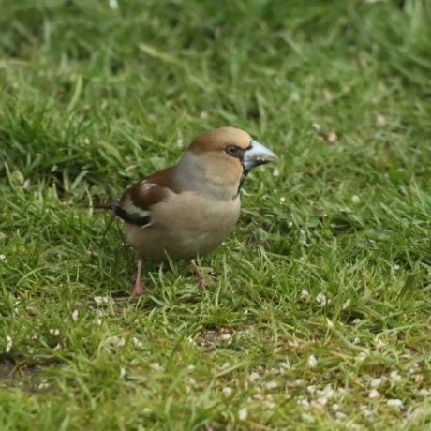
Hawfinch, Hillside, 3 Apr 2018. The second parish record after one in Jan 2018 which was included in TBOSBP. Photo by SH.

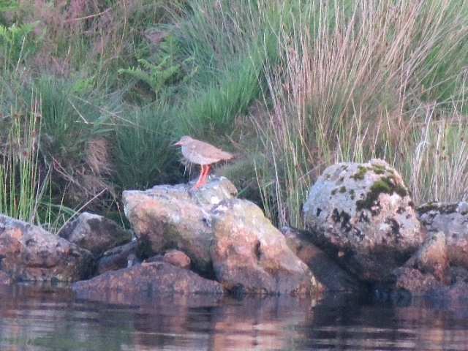
Redshank, Avon Dam, 16 Jul 2020. The first parish record. Photo by PR.

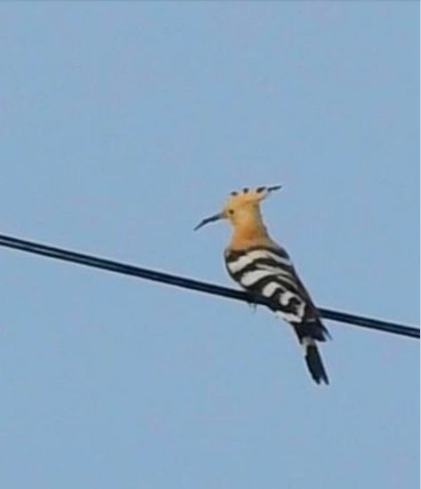
Hoopoe, Upper Webland Farm, 25 Oct 2023. The fourth parish record. Photo by SP.

‘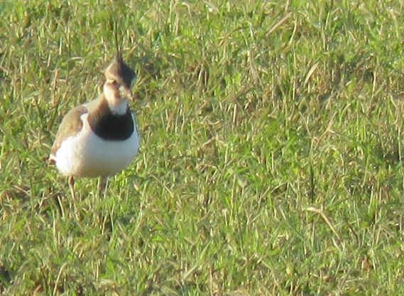
Lapwing, Elwell, 19 Jan 2024. Recorded in eight squares since 2017, but in none during 2014−6. Photo by PR.

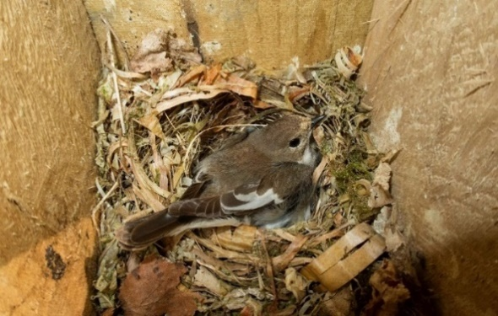
Pied Flycatcher, female on nest in Glaze valley box, 19 May 2018. The first parish breeding record since at least 2014. Photo by DS.

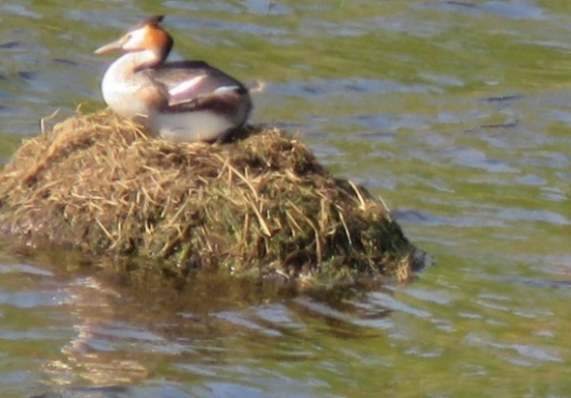
Great Crested Grebe on nest, Avon Dam, 2 Jun 2022. The first parish breeding record. Photo by PR.

Appendix 1. Species that have been recorded in every year since 2014. G=Great, L=Lesser and Sp=Spotted.

Barn Owl
Black Redstart
Blackbird
Blackcap
Blue Tit
Bullfinch
Buzzard
Canada Goose
Carrion Crow
Chaffinch
Chiffchaff
Coal Tit
Collared Dove
Common Sandpiper
Cormorant
Cuckoo
Dipper
Dunnock
Fieldfare
G. Sp. Woodpecker
Garden Warbler
Goldcrest
Golden Plover
Goldfinch
Goosander
G. Black-backed Gull
G. Crested Grebe
Great Tit
Green Woodpecker
Greenfinch
Grey Heron
Grey Wagtail
Herring Gull
Hobby
House Martin
House Sparrow
Jackdaw
Jay
Kestrel
Kingfisher
L. Black-backed Gull
Lesser Redpoll
Linnet
Little Grebe
Long-tailed Tit
Magpie
Mallard
Marsh Tit
Meadow Pipit
Merlin
Mistle Thrush
Moorhen
Mute Swan
Nuthatch
Peregrine
Pheasant
Pied Flycatcher
Pied Wagtail
Raven
Red Kite
Redstart
Redwing
Reed Bunting
Ring Ouzel
Robin
Rook
Siskin
Skylark
Snipe
Song Thrush
Sparrowhawk
Spotted Flycatcher
Starling
Stock Dove
Stonechat
Swallow
Swift
Tawny Owl
Teal
Tree Pipit
Treecreeper
Wheatear
Whinchat
Whitethroat
Wigeon
Willow Warbler
Woodcock
Woodpigeon
Wren
Yellowhammer

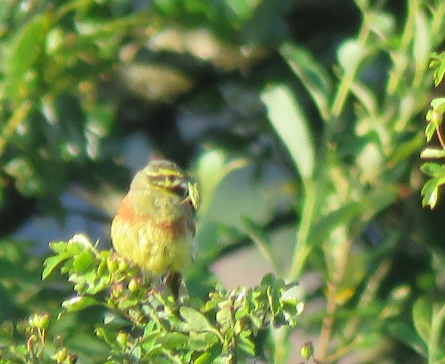
Cirl Bunting, male carrying food, Brent Hill, 10 Jul 2025. Photo by PR

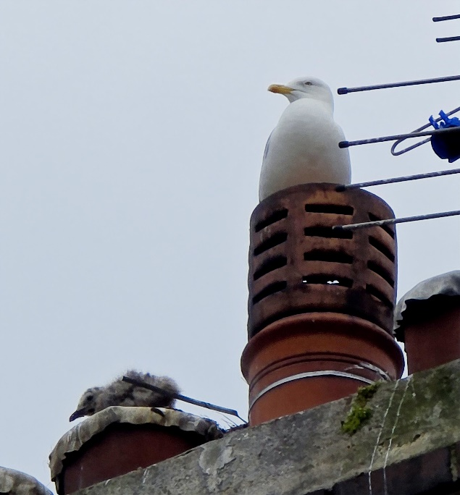

Herring Gull with young, Corn Park, 9 Jun 2025. Photo by TL

Appendix 2. The annual occurrence of rare and scarce species in the South Brent parish area 2014–25, including number of years recorded (N). Those not included in the list of parish species or in year totals are in grey, those in red are new to the parish since 2017 and those in blue are new to the survey (since 2017).
2014 to 2023 | N | ‘14 | ‘15 | ‘16 | ‘17 | ‘18 | ‘19 | ‘20 | ‘21 | ‘22 | ‘23
Black-headed Gull | 7 | ● | ● | ● | ● |  |  | ● | ●
Brambling | 9 |  | ● | ● | ● | ● | ● | ● | ● | ● | ●
Cetti's Warbler | 2 |  |  |  |  |  |  |  | ? | ●
Cirl Bunting | 6 |  |  | ● |  |  | ● |  |  | ● | ●
Common Rosefinch | 1 |  |  |  |  |  | ●
Coot | 3 |  | ● | ● |  |  | ●
Crossbill | 2 |  |  |  |  |  | ● | ●
Curlew | 2 | ● |  |  |  |  |  |  |  |  | ●
Dartford Warbler | 2 | ● | ●
Firecrest | 11 | ● |  | ● | ● | ● | ● | ● | ● | ● | ●
Golden Oriole | 1 |  |  |  |  |  |  |  | ●
Goshawk | 7 | ● | ● |  |  |  | ● | ● | ● |  | ●
Grasshopper Warbler | 10 | ● | ● | ● |  | ● | ● | ● | ● | ● | ●
Green Sandpiper | 5 |  | ● | ● |  |  | ● |  |  | ●
Greenshank | 1 | ●
Hawfinch | 1 |  |  |  |  | ●
Hen Harrier | 7 |  | ● | ● |  | ● |  | ● |  | ● | ●
Hoopoe | 1 |  |  |  |  |  |  |  |  |  | ●
Jack Snipe | 3 |  | ● | ● |  |  |  |  |  | ●
Lapwing | 5 |  |  |  | ● |  | ● |  | ● | ●
Lesser Whitethroat | 1 |  | ●
Little Egret | 5 | ● | ● | ● |  |  |  |  | ● | ●
Little Owl | 6 | ● | ● | ● | ● | ● |  | ● |  |  | ●
Little Ringed Plover | 1 |  | ●
Marsh Harrier | 2 |  |  | ● |  |  |  |  | ●
Nightjar | 3 |  |  |  |  | ● | ● | ●
Osprey | 4 |  | ● | ● |  | ● |  | ●
Oystercatcher | 1 |  |  |  |  |  |  |  |  |  | ●
Pintail | 2 |  | ● | ●
Red-legged Partridge | 7 | ● | ● | ● | ● |  |  | ● | ● | ●
Red-backed Shrike | 2 |  |  |  | ● |  |  |  | ●
Red-crested Pochard | 1 |  |  |  | ●
Red Grouse | 2 | ● |  |  |  |  | ●
Redshank | 2 |  |  |  |  |  |  | ●
Reed Warbler | 1 |  |  |  |  | ? |  |  |  |  | ●
Sand Martin | 7 | ● | ● | ● |  |  |  | ● |  | ● | ●
Sedge Warbler | 8 | ● | ● | ● | ● |  |  | ● | ● |  | ●
Shelduck | 1 |  |  |  | ●
Short-eared Owl | 4 |  | ● | ● | ● | ●
Shoveler | 1
Snow Bunting | 1 |  |  | ●
Tufted Duck | 4 |  |  | ● |  |  | ● | ●
Whimbrel | 2 |  |  |  |  |  |  |  |  | ●
Willow Tit | 2 | ● |  | ●
Woodlark | 1 |  |  |  |  |  |  |  |  | ●
Wood Warbler | 1 |  |  | ●
Wryneck | 3 |  | ● | ●
Yellow Wagtail | 5 | ● | ● |  | ● | ● | ●
Yellow-browed Warbler | 2 |  | ● | ●
Harrier, unidentified | 3 | ● |  |  | ● |  |  |  |  | ●
‘Italian’ Sparrow | 2 |  |  |  |  |  |  | ● | ●
Lammergeier | 1 |  |  | ●
White-fronted Goose | 1 |  |  |  |  |  |  | ●
Number of species |  | 16 | 22 | 25 | 13 | 11 | 14 | 17 | 13 | 14 | 14
Continued/
2024 to 2033 | ‘24 | ‘25 | ‘26 | ‘27 | ‘28 | ‘29 | ‘30 | ‘31 | ‘32 | ‘33
Black-headed Gull | ●
Brambling
Cetti's Warbler |  | ●
Cirl Bunting | ● | ●
Common Rosefinch
Coot
Crossbill
Curlew
Dartford Warbler
Firecrest | ● | ●
Golden Oriole
Goshawk |  | ●
Grasshopper Warbler |  | ●
Green Sandpiper |  | ●
Greenshank
Hawfinch
Hen Harrier |  | ●
Hoopoe
Jack Snipe
Lapwing | ●
Lesser Whitethroat
Little Egret
Little Owl
Little Ringed Plover
Marsh Harrier
Nightjar
Osprey
Oystercatcher
Pintail
Red-legged Partridge
Red-backed Shrike
Red-crested Pochard
Red Grouse
Redshank |  | ●
Reed Warbler
Sand Martin | ●
Sedge Warbler |  | ●
Shelduck
Short-eared Owl
Shoveler |  | ●
Snow Bunting
Tufted Duck |  | ●
Whimbrel | ●
Willow Tit
Woodlark
Wood Warbler
Wryneck |  | ●
Yellow Wagtail
Yellow-browed Warbler
Harrier, unidentified
‘Italian’ Sparrow
Lammergeier
White-fronted Goose
Number of species | 6 | 12

